URL = <http://sotd.us/austinvanraden/CIS4655C-WebDev/Module%204/Activity/Mod4Activity.html>

Github repo = <https://github.com/AustinVanStroodleBerry/CIS4655C-WebDev/tree/master/Module%204/Activity>

First Page

The first change was making the top row a jumbotron class. The second change was adding the card, which would be row three, the first column. The button in the card brings you to the second page, which the second page has a button to go back to the homepage. There were two labels added as well. The final change would be the badges on the social media buttons below.

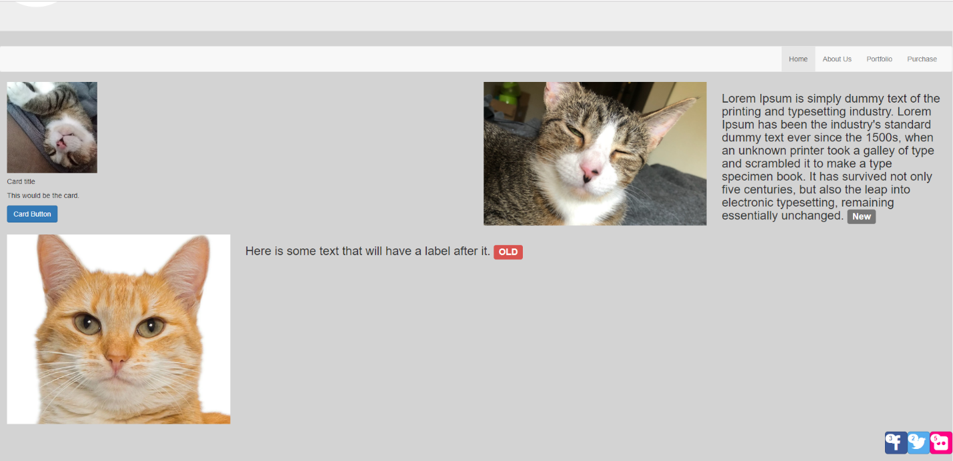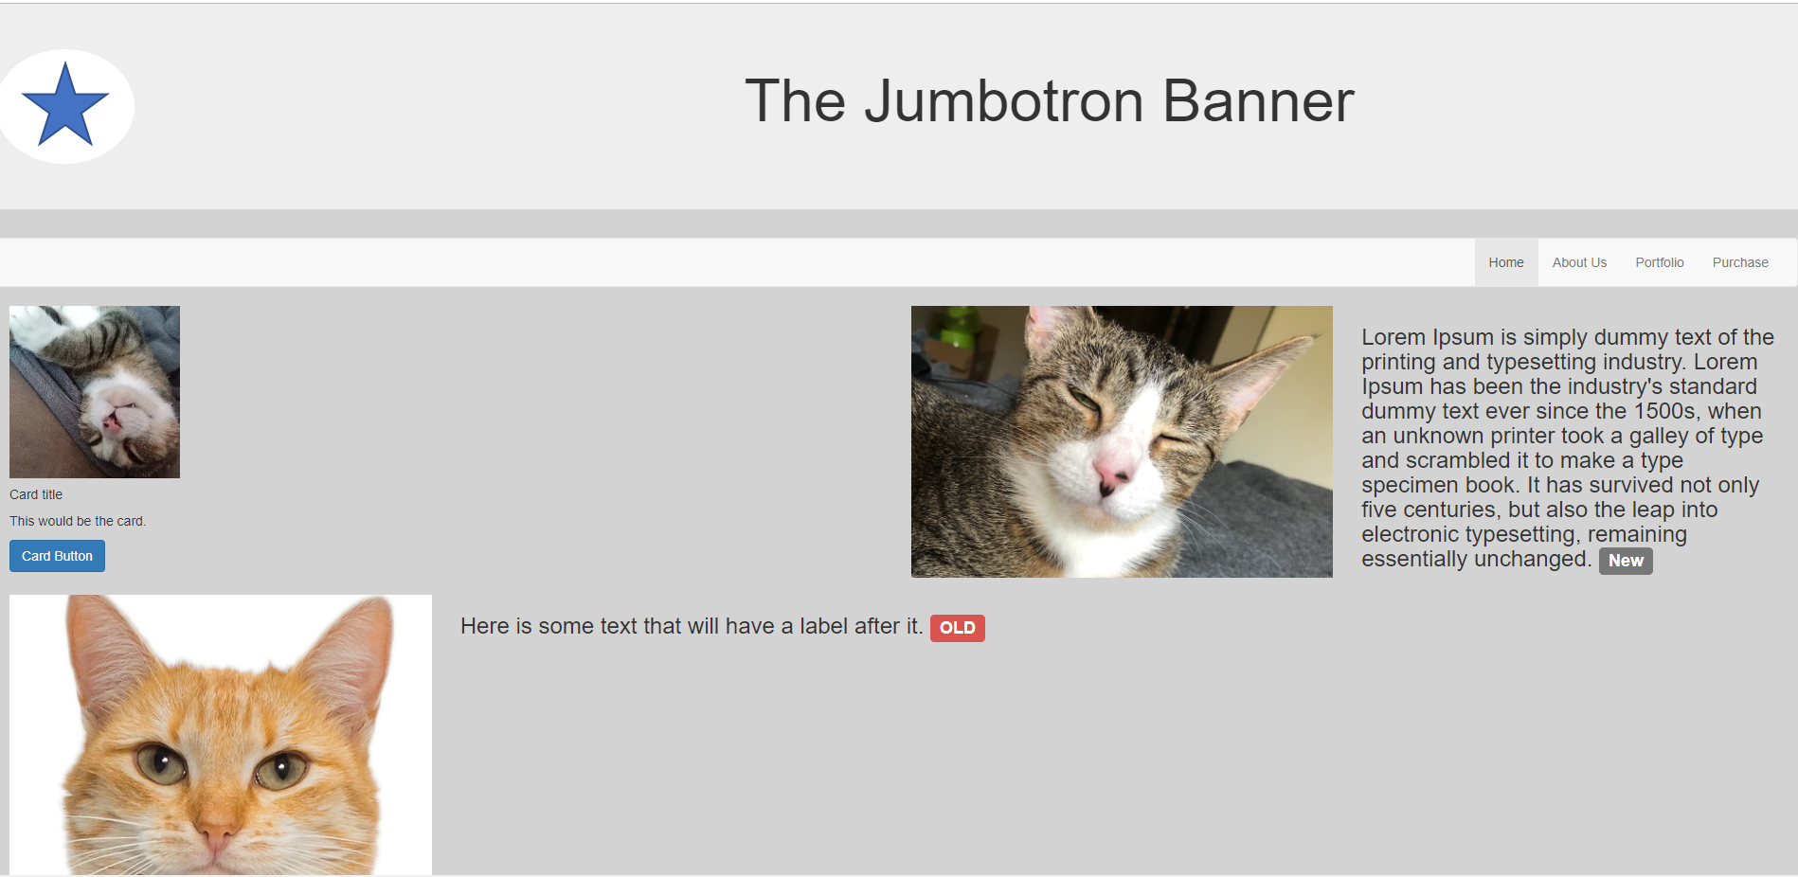

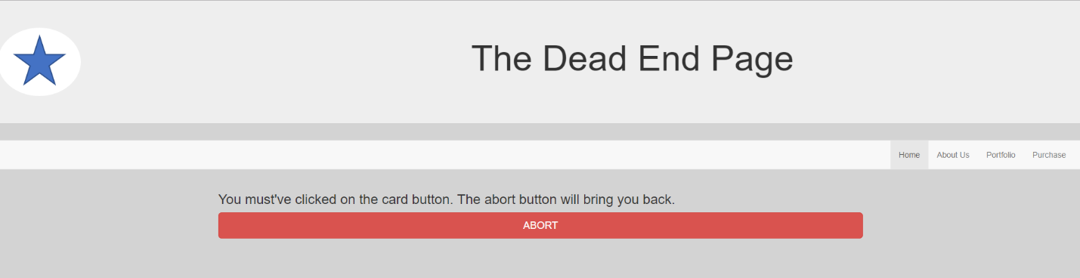Second Page

Ipad view

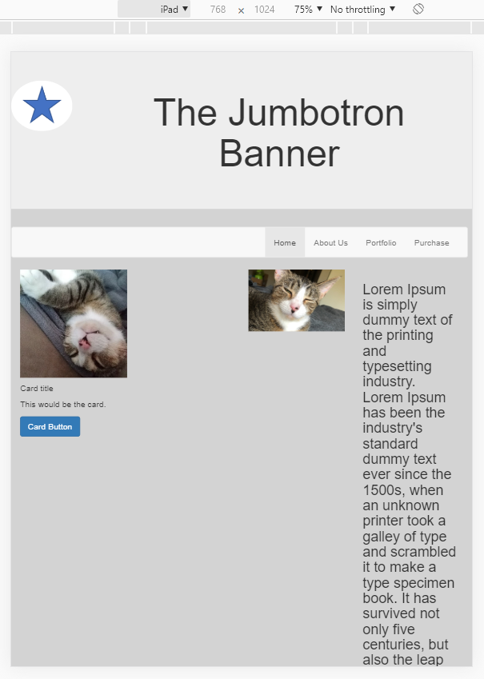

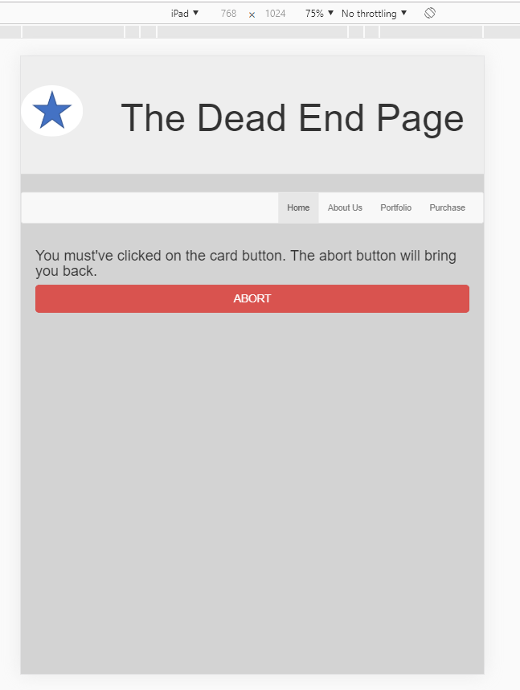

Galaxy S5 view

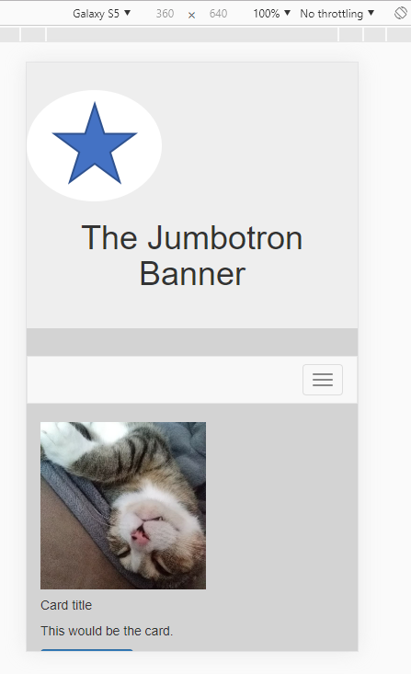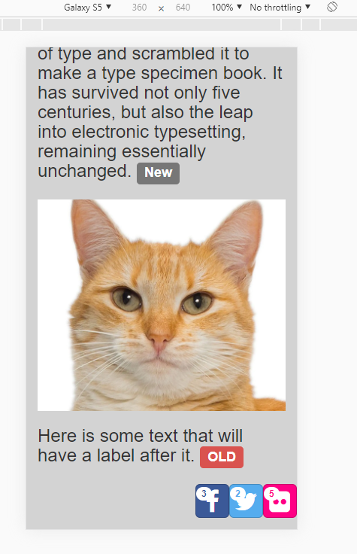

Second Page

